
Interface definition MixCont ←→ SAP Business One

Project / Customer : QEW Engineered Rubber B.V.
Author : Pieter Markus
Provide Business Solutions
Date : 29 October 2013
Versie-info:
Version | Date | Author | Remarks
0.1 | 2013/10/29 | Pieter Markus | Initial revision
0.2 | 2013/11/13 | Pieter Markus | Additions, translation
0.3 | 2013/11/20 | Pieter Markus | Revised content, explanations to MixCont questions
0.4 | 2013/12/04 | Pieter Markus | Finalised table description and datamodel

Table of contents
Preface 3
Functional definition of the interface 4
1.1 Raw Materials from MixCont towards SAP Business One 4
1.2 Recipe’s from MixCont towards SAP Business One 5
1.3 Item Prices from SAP Business One towards MixCont 7
1.4 Supplier data from SAP Business One towards MixCont 8
Technical definition of the interface 9
Data model of the interface 10
Raw Material information from MixCont to SAP Business One 10
Recipe information from MixCont to SAP Business One 12
Item Price information from SAP Business One to MixCont 14
Vendor information from SAP Business One to MixCont 14

Preface

On behalf of the SAP Business One / FourthShift Edition implementation at QEW Engineered Rubber, there is the need to create an (automated) interface between the MixCont application and SAP Business One. The interface consists of a number of ‘objects’ that need to be transferred. For each of the objects, we have defined which one of the two systems will be leading in data definition, and which of the systems is the receiver. Some of the objects will be transferred from MixCont to SAP Business One, where others will be transferred from SAP Business One to MixCont. This definition will also lead to creating work instructions for the user how data should be entered and how the data flows through the interface to the other end.
In this document the functional and technical specs of the interface are defined. The interface will be designed and built in modules, so that at a later phase objects can be added to the interface, when needed.
Initially at the scope-definition phase, it was defined that the most critical part of the interface is the interchange of recipe’s from MixCont to SAP. This will be the first interface to be developed. During further investigation, and meetings regarding the interface, it is made clear that there is a wish to have an interface for data related to recipe’s, which will make data entry in both applications easier, and make data between the two systems more consistent. In the remainder of this document we will address the data flow as ‘streams’.
The following streams have been defined:
- Raw material (Item Master data) MixCont towards SAP Business One
- Recipe’s from MixCont towards SAP Business One
- Item Prices (pricelist info) from SAP Business One towards MixCont
- Vendor Information from SAP Business One towards MixCont
The interface will be based on a (set of) intermediate table(s) that contain the data that should be transferred between both applications. There will be no direct transactions from one application (SAP or MixCont) to the other; both application will read data from and write data to the intermediate table(s). This will be further explained in this document. Both ends of the interface should be designed in a way that besides automated transfer, transfer based on user action (a ‘transfer-button’) is also possible.

Functional definition of the interface

Currently, four streams have been defined in the interface between MixCont and SAP Business One:
- Raw material (Item Master data) from MixCont towards SAP Business One
- Recipe’s from MixCont towards SAP Business One
- Item Prices (pricelist info) from SAP Business One towards MixCont
- Supplier Information from SAP Business One towards MixCont.

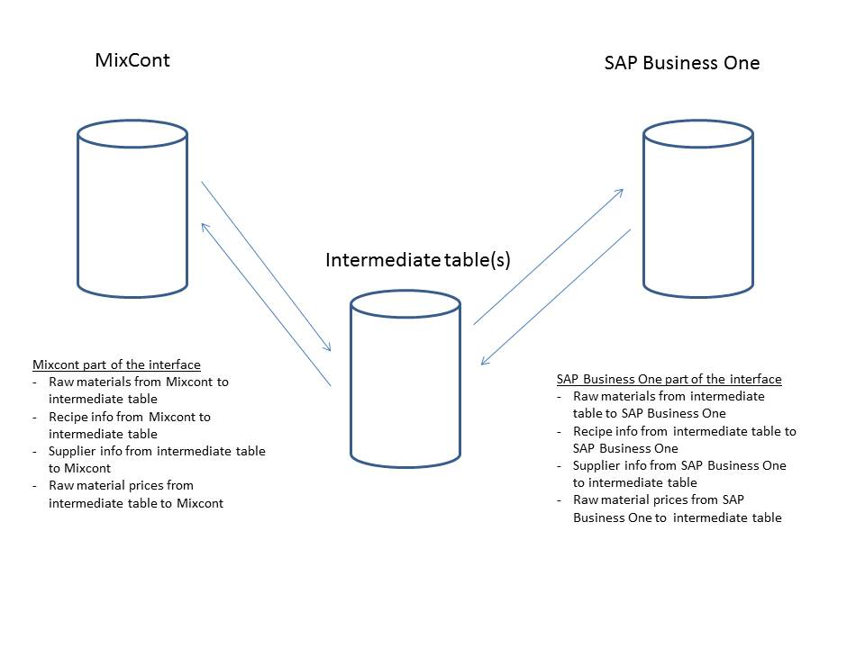

Raw Materials from MixCont towards SAP Business One

Raw materials are defined in MixCont. In order to prevent we need to maintain two systems, there is a wish to transfer raw materials from MixCont towards SAP Business One. The following rules and conventions are applicable:
- MixCont is leading for the fields that are transferred to SAP Business One
- New or changed material records in MixCont are transferred to the intermediate table to be picked up by the SAP Business One part of the interface.
- When a raw material item does not exist in SAP Business One, the SAP Business One part of the interface will create it.
- When a raw material exists in SAP Business One, the Business One data will be modified along with the data from MixCont, but only for the fields that are put in the intermediate table by the MixCont part of the interface.
- Data in SAP Business One needs to be completed by the user after it is transferred from MixCont
- In the interface we can define a number of defaults for all raw material items. These are defaults to SAP Business One related tables and forms
- To prevent timing conflicts, the interface will start with transferring raw material data before Bills of manufacturing (recipe’s) are transferred
- Deletion of items through is not recommended; In Mixcont these items are marked as ‘inactive’, the item will be treated by the interface and marked as ‘Being Phased Out’ in SAP Business One’, so the user can do additional checks in SAP (inventories, current workorders, purchase orders, recipe’s etc.).
- Raw materials are defined in SAP Business One with 6 characters (e.g. 3-0419). In MixCont, the itemnumber is defined without the dash (30419) The interface will put the dash between the first and second character of the item number. This will be done on the SAP side of the interface.
- Some of the fields in SAP Business One will not be provided by MixCont but are set to a default value in SAP Business One by the SAP part of the interface.
- As a part of the raw material transfer, also the ‘business partner catalogue’ table will be filled: this is the link between a raw material, its vendor(s) and tradename(s)

The list of fields to be transferred will be described in the Technical definition, later in this document.

Recipe’s from MixCont towards SAP Business One

In this stream the recipe data from MixCont is transferred to SAP Business One. The interface is active for new recipe’s and for modifications to existing recipe’s. The following rules and conventions apply:
- MixCont data is leading for the fields that are included in the interface
- Materials are included in the interface, with a number of additional fields to be used in SAP Business One for defining the routing step in the Bill Of Manufacturing
- In SAP Business One, there is an item number for the recipe, which has an item number with a leading ‘R’ (e.g. R12-0-0034 as compared to the item 12-0-0034). For the MixCont part of the interface this is not an issue, this will be handled by the SAP part of the interface. The information from the MixCont recipe are saved in SAP Business One ‘R..’ item number. In SAP Business One there is a 12-0-0034 item next to the R12-0-0034 item. The R12-0-0034 item is used for maintenance of the recipe.
- The interface validates if the recipe item (The R.. itemnumber) exists in the SAP Business One database. If the item does not exist in SAP Business One, the item is duplicated from the same item number without the leading ‘R’.
- The SAP Business One part of the interface validates if all components of the recipe exist in the SAP Business One database. If one or more components on the recipe does not exist in SAP Business One, the complete recipe is rejected by the interface. This is to prevent the recipe is incomplete in SAP Business One. The MixCont part of the interface does not have any validation against the SAP database: new and changed recipe’s are completely inserted into the intermediate table
- Recipe’s are defined in SAP Business One as make items with a leading ‘R’ before the item number. This does not have an impact on MixCont operations, but is needed for the processflow in SAP Business One.
- When a recipe is changed in MixCont, the complete recipe needs to be transferred. In SAP Business One, the recipe will be deleted and created, in order to prevent inconsistencies.
- When the recipe is transferred to SAP Business One, the weight is calculated as the sum of the weights of all components. This calculation is also done in MixCont, and can be transferred as part of the recipe interface. The weight is updated in the Item Master on the item number as Lot Size Multiple. On the SAP Business One part of the interface, a validation will be done to verify if the sum of the weights of all components match with the total weight of the recipe.
- When the material components are transferred to SAP Business One, the fields ‘Balance ID’ and ‘Silo ID’ are also transferred to make an indication in SAP Business One on which routing step (Add phase) the material is needed. This needs to be verified by the user in SAP Business One
- The interface only looks at new or changed recipe’s. Recipe’s will not be deleted, the interface will modify the Item status of the ‘R’ item to ‘Inactive’. The user needs to go into SAP Business One to check if there are further actions required in SAP.
- In MixCont, a recipe can have a flag ‘P’ ,’H’, ‘R’. Only the ‘P’ recipe’s will be transferred, this flag will not be transferred to SAP
*: SAP Business One is capable of maintaining revisions of items and Bills of Manufacturing. In MixCont this is implemented by having the revision marker as the first 2 characters of the recipe item. When a new revision is defined in MixCont, this will be a new item number in SAP Business One. For these items, the Bill of Material in SAP will be deleted and recreated. For items that we want to keep revisions in SAP Business One the interface can create a new revision with the new bill of material. At the moment it is not clear yet if the interface needs to consider revisions when transferring recipe’s from MixCont to SAP.
De list of fields to be transferred will be described in the technical definition, further in this document.

Item Prices from SAP Business One towards MixCont

This stream of the interface is related to prices of raw materials. Item prices are maintained in SAP Business One in pricelists. Next to pricelists, there is a standard costprice for all items, which is used for inventory valuation. This standard item price will also be the price that is to be transferred from SAP Business One to MixCont, for calculation of recipe’s.
In SAP Business One, pricelists can be maintained per item/vendor combination. At the moment it is decided that the standard cost of the raw materials will be transferred with no reference to vendor and/or tradename
This will be described in a later phase, for now the technical specification will be based on the fact that items with standard cost prices will be transferred to MixCont.

Supplier data from SAP Business One towards MixCont

For maintenance of raw materials and recipe’s in MixCont there is a wish to be able to use supplier data in MixCont. For Supplier data, SAP Business One is the leading system. Supplier data will be transferred from SAP Business One to MixCont. In MixCont, the ‘preferred’ or ‘approved’ supplier can then be selected on a raw material, and this information can be transferred back into SAP Business One. (This could change the logic of current recipe and material data manipulation. Must be carefully checked on MixCont side. )
Supplier data is available in MixCont as referral data. At the moment we do not specificly have the information on which fields are available in MixCont, and which fields are needed. For now we restrict the interface to name and address data of the suppliers. This will be further defined in the technical definition in the next chapter of this document. (In MixCont there is possibility to has unlimited amount of additional information like links to files whish specify the specks for materials/norms/etc. )

Technical definition of the interface

In this chapter, the technical definition of the interface is described. The interface will be based on a number of ‘transaction’ tables, and an administrative table for the interface itself. In this document we have described four main flows (streams) to be done in the interface. From data modelling perspective each stream can consist of one or more tables. This is described in the following paragraphs, per stream.

The tables will reside on the SQL Server on the MixCont server. This decision is made based on the following:
- To prevent (backward) compatibility issues: MixCont is on SQL Server 2000, SAP is on SQL Server 2008. From SQL Server 2008 we can connect to SQL Server 2000 (backwards compatible), but we may have compatibility issues doing it the other way
- Write actions to the interface database will be done mainly by the MixCont application (changes of materials and recipe’s) and this is more critical and more frequent than write actions from SAP (Supplier info and item prices). Connection to the database is more critical on behalf of MixCont

We will create a linked-server relation between the SAP and MixCont SQL Servers, so from the SAP Server we can read/write to the interface tables on the MixCont server.

Data model of the interface

Raw Material information from MixCont to SAP Business One
For Raw material synchronisation, two tables have been defined.
Table: Raw_Material
Name | Datatype | MC | Description | Comment
ItemCode | Nvarchar(20) | varchar(12) | ItemCode | Normally 5digitals chars.
ItemName | nvarchar(100) |  | Description of the item | Description in MixCont
PreferredLocation | Nvarchar(20) |  | Preferred inventorylocation | There is as “warehouse_location” as possible option for free infor. Always (as a rule )N.V.T . No such special field in MC database.
ShelfLifeDays | Int |  | Shelf life days – for calculating the Lot Expiration date on goods receipt | Shelf life in days from MixCont. It is stored in Months but will be multiplied by 30 in the MixCont export.
GroupTechnologyCode | Nvarchar(20) |  | Material Category
FamilyItemNumber | Nvarchar(20) |  | Category description
FamilySubGroup | Nvarchar(6) |  | Polymer block
NMFC | Nvarchar(6) |  | ADR Class
NMFC_SubCode | Nvarchar(2) |  | Packaging group
ECCN | Nvarchar(15) |  | UN Code
ItemReference1 | Nvarchar(25) |  | CMR Code
DateExport | Datetime |  | The date/time the record is exported from MixCont
DateProcessed | Datetime |  | The date/time the record is processed by SAP
Status | Nvarchar(200) |  | Processing status | NULL when inserted, updated by SAP with status. Can be put to ‘TEST’ when exported from MixCont to prevent processing in SAP
ID | Int |  | Unique Identifier of the record

A number of fields is not included in the interface from MixCont, but will be put on default values by the interface when the record is inserted into SAP Business One:
Name | Datatype | Description | Comment
ItemUoM | Nvarchar(10) | Unit of Measurement | Default to ‘kg’
ProcurementCode | Nvarchar(1) | Procurement code (M=Make, B=Buy) | Default to ‘B’
LotSizeMin | Decimal(19,6) | Minimum order quantity | Default = 1
LotSizeMultiple | Decimal(19,6) | Order multiple at supplier | Default = 1
RetestDays | Int | Retest days | Defined as the ShelfLifeDays - 10
Table: Raw_Material_Vendor
Name | Datatype | MC | Description | Comment
ItemCode | Nvarchar(20) | varchar(12) | ItemCode
SupplierNo | Nvarchar(20) |  | Supplier Number (related to SAP Business Partner code)
TradeName | Nvarchar(100) |  | Tradename of the item as it is ‘known’ by the vendor
DateExport | Datetime |  | The date/time the record is exported from MixCont
DateProcessed | Datetime |  | The date/time the record is processed by SAP
Status | Nvarchar(200) |  | Processing Status | NULL when inserted, updated by SAP with status. Can be put to ‘TEST’ when exported from MixCont to prevent processing in SAP
ID | Int |  | Unique identifier of the record | Primary key

Recipe information from MixCont to SAP Business One

Table: Recipe
Name | Datatype | MC | Description | Comment
ParentItemCode | Nvarchar(20) | varnvarchar(12) | Parent ItemCode (Recipe nr)
DateExport | Datetime |  | Date the record is exported from MixCont
DateProcessed | Datetime |  | Date the record is processed by SAP
Status | Nvarchar(200) |  | Processing status | NULL when inserted, updated by SAP with status. Can be put to ‘TEST’ when exported from MixCont to prevent processing in SAP
ID | Int |  | Unique identifier of the record | Primary key

Table: Recipe_Raw_Material
Name | Datatype | MC | Description | Comment
ParentItemCode | Nvarchar(20) | varnvarchar(12) | Parent ItemCode (Recipe nr)
PointOfUse | Nvarchar(8) |  | Point of use (routing step) | No such Variable. ?
ComponentItemCode | Nvarchar(20) | varnvarchar(12) | Component item code
RequiredQuantity | Decimal(19,9) |  | Required Quantity | Float
WorkInstructions | Text |  | Workinstructions | Backup for mixing plan
DateExport | Datetime |  | Date the record is exported from MixCont
DateProcessed | Datetime |  | Date the record is processed by SAP
Status | Nvarchar(200) |  | Processing status | NULL when inserted, updated by SAP with status. Can be put to ‘TEST’ when exported from MixCont to prevent processing in SAP
ID | Int |  | Unique identifier of the record | Primary Key

A number of fields is not included in the interface from MixCont, but will be put on default values by the interface when the record is inserted into SAP Business One:
Name | Datatype | Description | Comment
QuantityType | Nvarchar(1) | Quantitytype: I= per item, O=per order | Default to ‘I’

The OperationSequenceNumber in SAP links the raw material to a certain routing step. In MixCont, this is based on the SiloID and a specific sortorder. The MixCont part of the interface will translate to routing steps:
10 – Cleaning
20 – Chemical weighing (1)
21 – Chemical weighing (2)
22 – Chemical weighing (3)
30 – Mixing
Workinstructions are extracted by MixCont, this is the backup mixing plan in readable form for the operators to be printed on the workorder from SAP.

Item Price information from SAP Business One to MixCont

Table: Item_Price
Name | Datatype | Description | Comment
ItemCode | Nvarchar(20),char (12) | Item Code
ItemPrice | Decimal(19,6) ,float | Itemprice.
DateExport | Datetime | Date the record is exported from SAP
DateProcessed | Datetime | Date the record is processed by MixCont
Status | Nvarchar(200) | Processing status | NULL when inserted, updated by Mixcont with status. Can be put to ‘TEST’ when exported from SAP to prevent processing in MixCont
ID | Int | Unique Identifier of the record | Primary key

Vendor information from SAP Business One to MixCont
Table: Vendor
Name | Datatype | Description | Comments
VendorNo | Nvarchar(20) | Supplier number.
VendorName | Nvarchar(100)
Address | Nvarchar(100) | Address
ZipCode | Nvarchar(20) | ZipCode
City | Nvarchar(100) | City
Country | Nvarchar(100) | Country
Phone | Nvarchar(50) | PhoneNumber for company
Fax | Nvarchar(50) | Faxnumber for company
Email | Nvarchar(50) | Emailaddress of company
Website | Nvarchar(50) | Website address of company
DateExport | Datetime | The date the record is exported from SAP
DateProcessed | Datetime | The date the record is processed by MixCont
Status | Nvarchar(200) | Processing status | NULL when inserted, updated by SAP with status. Can be put to ‘TEST’ when exported from SAP to prevent processing in MixCont
ID | Int | Unique Identifier of the record | Primary key

For the transfer of contact persons, a separate table is defined:
Table: Vendor_Contacts
Name | Datatype | Description | Comments
VendorNo | Nvarchar(20) | Supplier number.
ContactName | Nvarchar(50) | Name of contact person
Position | Nvarchar(90) | Position | *
Phone | Nvarchar(50) | PhoneNumber for contactperson
Email | Nvarchar(50) | Emailaddress of contactperson
UpdateDate | Datetime | The date the contactperson was updated
DateExport | Datetime | The date the record is exported from SAP
DateProcessed | Datetime | The date the record is processed by MixCont
Status | Nvarchar(200) | Processing status | NULL when inserted, updated by SAP with status. Can be put to ‘TEST’ when exported from SAP to prevent processing in MixCont
ID | Int | Unique Identifier of the record | Primary key

*: The field ‘Position’ is used to filter the contacts we want transferred. Contacts with a position ‘Sales’ and ‘Technical Support’ are transferred to the interface for MixCont.

General Table: Interface_Trigger
Name | Datatype | Description | Comment
Datastream | Nvarchar(50) | Type of stream to be transferred | Indication of the type of data: Raw_Material; Recipe; Vendor_Info; Item_Prices
Sender | Nvarchar(50) | Sender of the transaction | ‘MixCont’, ‘SAP’
Receiver | Nvarchar(50) | Receiver of the transaction | ‘SAP’, ‘MixCont’
DateSend | Datetime | Date the records are inserted by Sender
DateProcessed | Datetime | Date the records are processed by Receiver
Status | Nvarchar(200) | Processing status | NULL when inserted, updated by receiver with status, can be put to ‘TEST’ to prevent processing by receiver
ID | Int | Unique identifier of the record | Primary key

Remarks
The table ‘Interface_Trigger’ is used for housekeeping. When the ‘sender’ part of the interface is started, the records are inserted into the appropriate tables, and when done a record is inserted into the Interface_Trigger table to notify the receiver that there is something to process. The receiving part of the interface is scheduled to look into this housekeeping table and as soon as there is something ‘to do’, the according module of that interface is started to transfer the data to the receiver. For the sender, writing into this table is the closing action of the export, because we do not want the receiver to start before the sender has finished writing.

